**2D Top Down Shooter Bolt in Unity Macro(aka scripts) explanation**

**Note: If you want to put your own Bolt project into the github remember to remove the library tag in the .gitignore so that the Bolt Library won’t be deleted and cause you a lot of trouble. Also, remember to update your package manager if you see anything that is different/not working.Lastly,if there is any wrong opening in Unity, just quit the application and rerun it. If it’s an issue with the layout, just reset back to default layout and reopen it again.**

**Those Macro with the word “Embed” in this document means it can only be found in the gameobject and not in the Macro folder.**

**Main menu UserInterface**

**Song Manager Embed Macro**

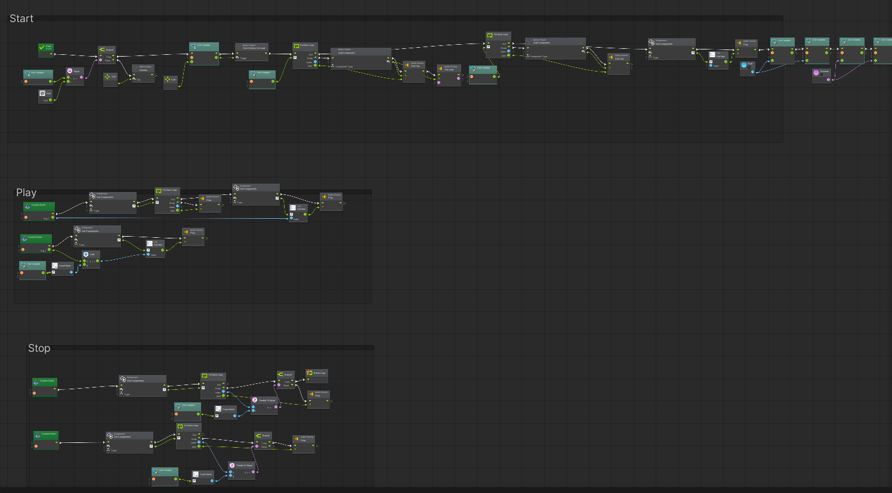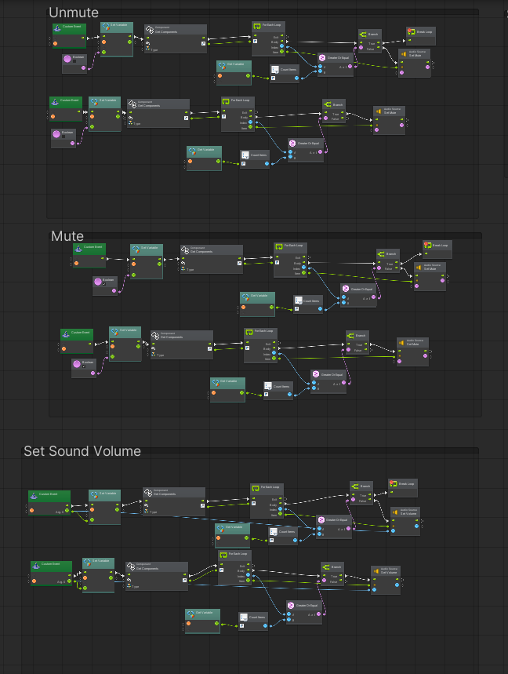

Having the start event to add the audio source component into the song manager from both BGM and Sound effect list and making itself not being destroyed as the scene changes and destroys the second song manager afterwards when changing scene beforehand. The music is being played by getting the whole list of audio source components in the song manager and playing the number in that whole list of arrays (E.g. BGM List contains BGM1 and BGM2 while SFX List contains SFX1, when you want to play SFX1, you call PlaySFX custom event and link the gameobject as the songmanager and key in the variable 0, thus in that custom event, it will get list of songs of BGM number and add into the value that you have key in which is 0 which you will get 2 and play it from in the whole audio source component array list format (BGM1 = 0, BGM2 = 1 and SFX1 =2)). All the custom functions in the macro are the same way of getting which list to be adjusted or to be played or stop.

**Play Game Embed Macro**

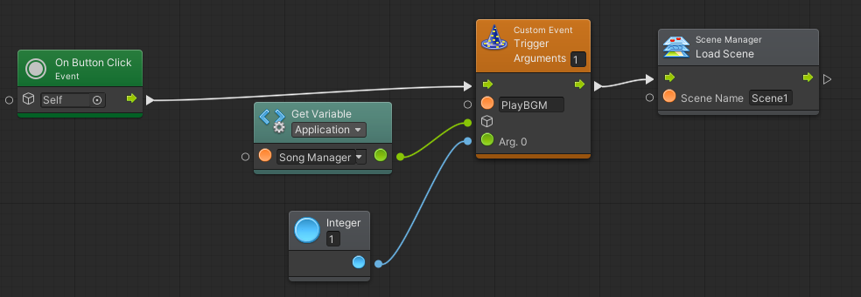

It's being used to transit scenes from the main menu into the game

**Quit Embed macro**

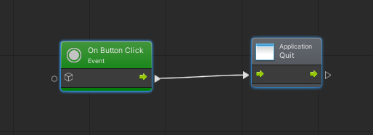

Being used to quit and close the application.

**Music Setting Option Embed Macro**

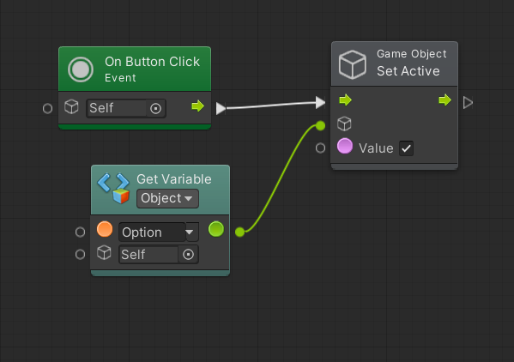

Being used to open up and close Music setting menu

**Setting Music and Sound effect embed macro**

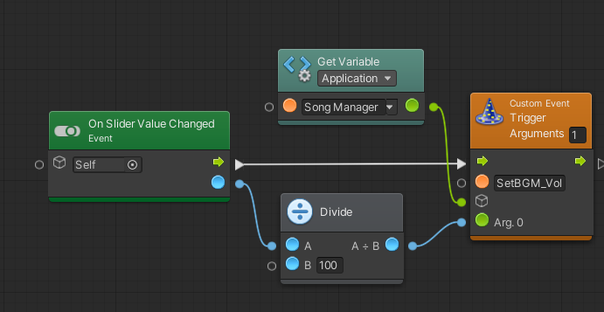

Being used to adjust the volume of the music and sound effects through slider and update it into the the song manager

**Mute and Unmute Music and Sound Effects embed macro**

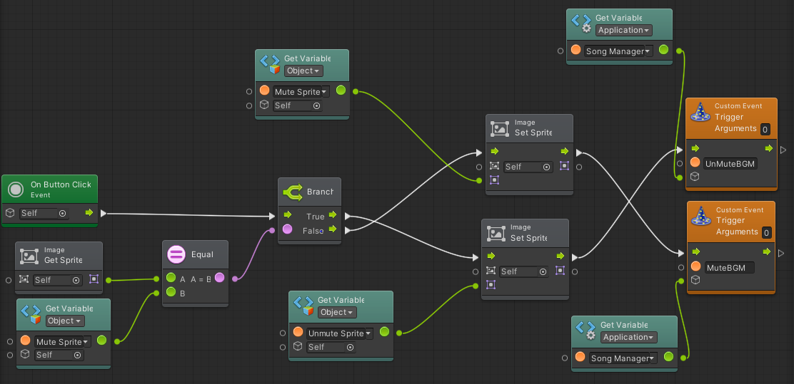

Being used to mute and unmute the background music and the sound effects respectively and update it into the song manager.

**Volume Indicator Embed Macro**

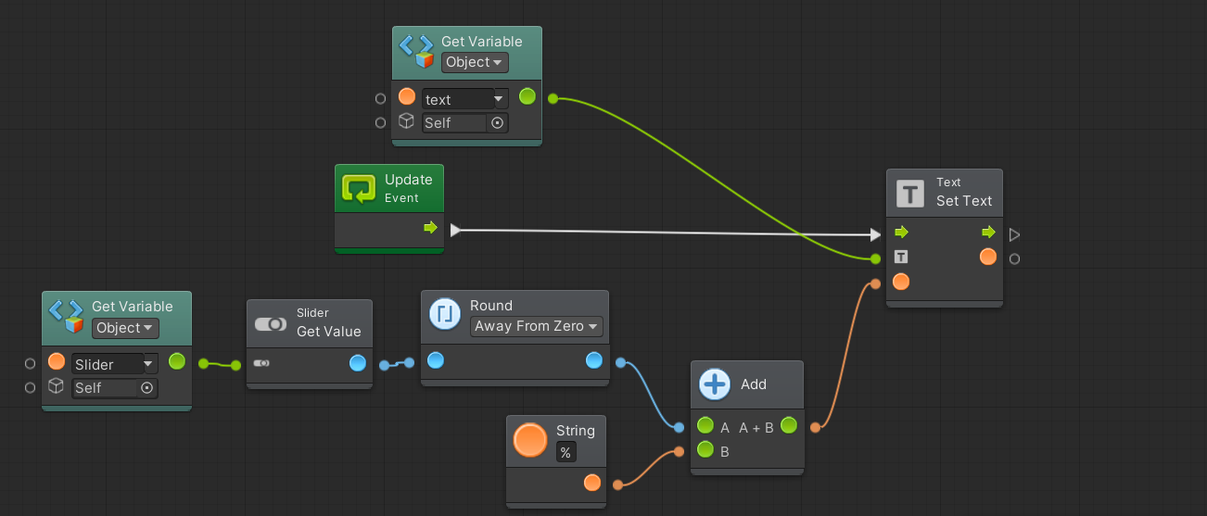

Being used to ui display the sound volume of the background music and sound effects.

**GameUI Embed Macro**

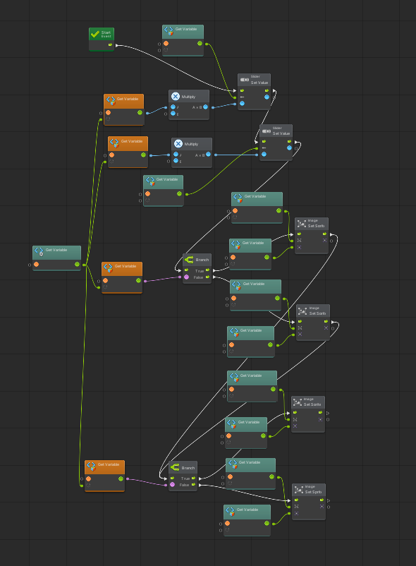

Being used to get all the relevant information from the song manager gameobject such as the music is mute or unmute and the volume of the sound and set it into the music setting.

**Gameplay UserInterface**

**Going back to main menu embed macro**

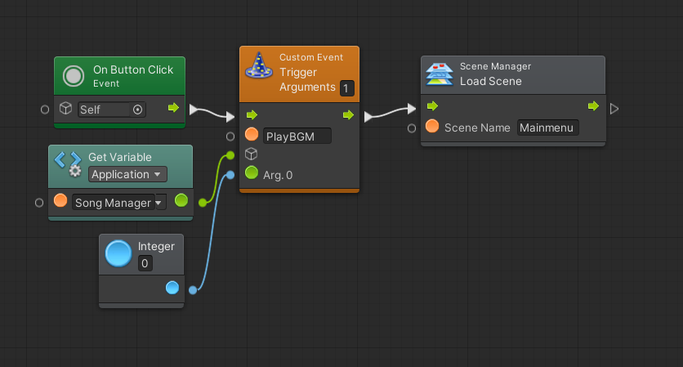

This macro is placed in the win ui button, lose ui button and also inside the pause menu button to bring the player back to the game main menu.

**Resume Embed Macro**

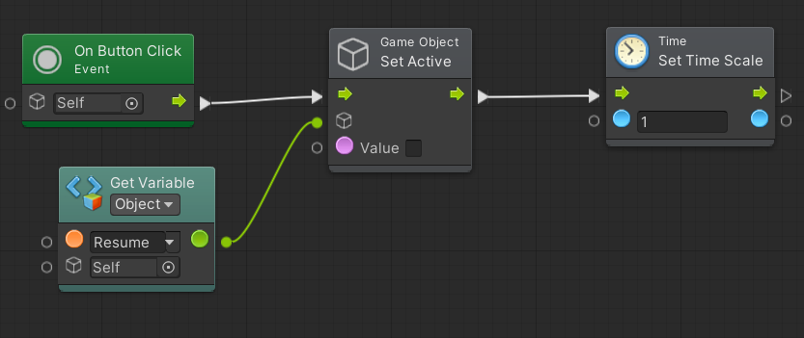

Being used to resume the game and unpause the game by setting the timescale back to 1.

**Music Setting Option**



Being used to open up and close Music setting menu

**Setting Music and Sound effect embed macro**



Being used to adjust the volume of the music and sound effects through slider and update it into the the song manager

**Mute and Unmute Music and Sound Effects embed macro**



Being used to mute and unmute the background music and the sound effects respectively and update it into the song manager.

**Volume Indicator Embed Macro**



Being used to ui display the sound volume of the background music and sound effects.

**GameUI Embed Macro**



Being used to get all the relevant information from the song manager gameobject such as the music is mute or unmute and the volume of the sound and set it into the music setting.

**Gameplay**

**Coin Macro**

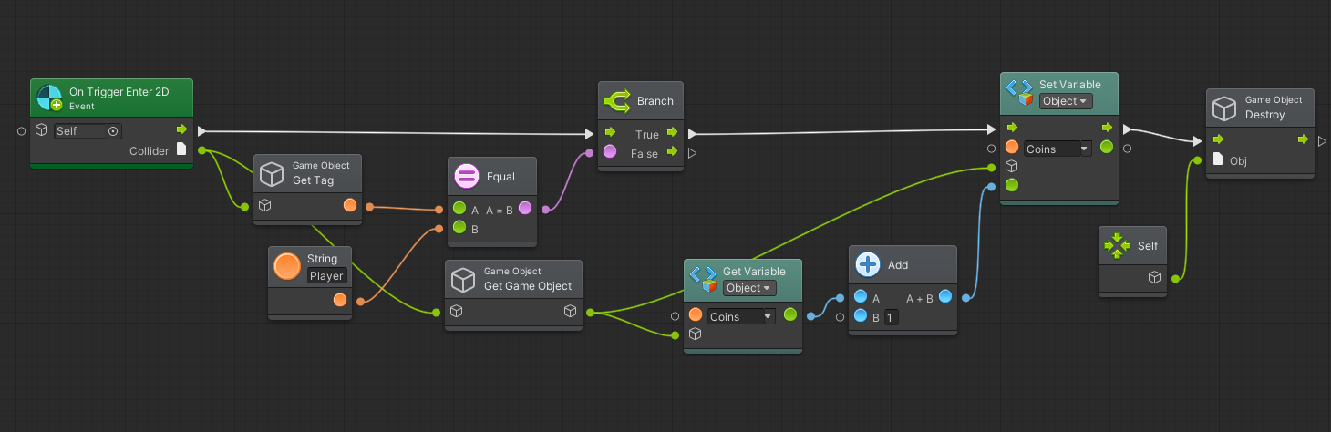

Explanation: When the player collides with the coin gameobject, the coin gameobject would be destroyed and the player will gain 1 coin.

**Chest Macro**

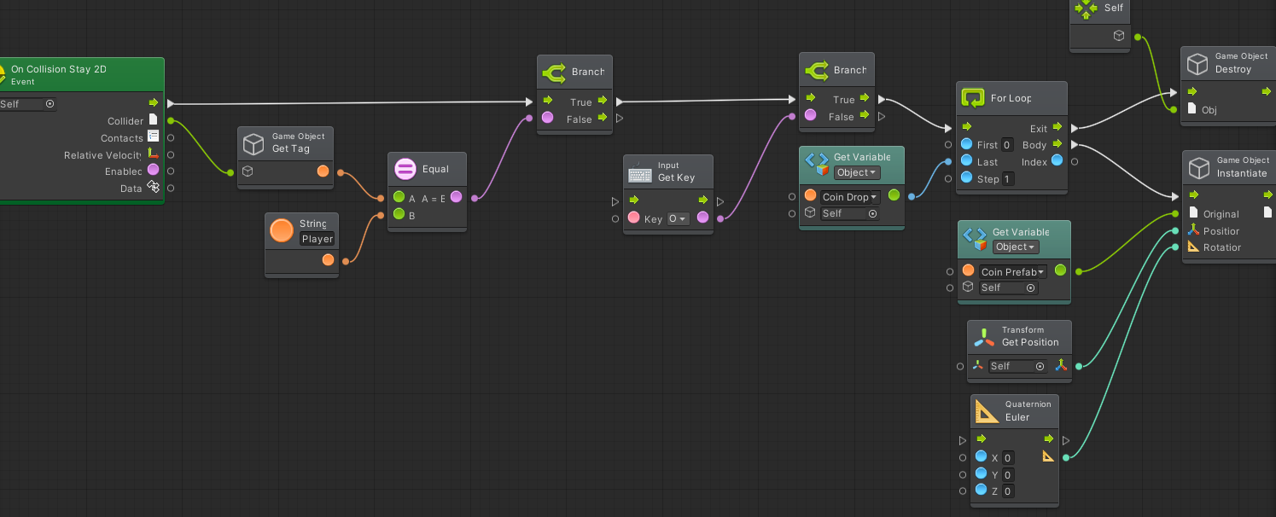

Explanation: When the player collides and stays within the chest gameobject collision, if the player presses O key, the chest will be destroyed and spawn the number of coins according to the Coin Drop variable.

**Key Macro**

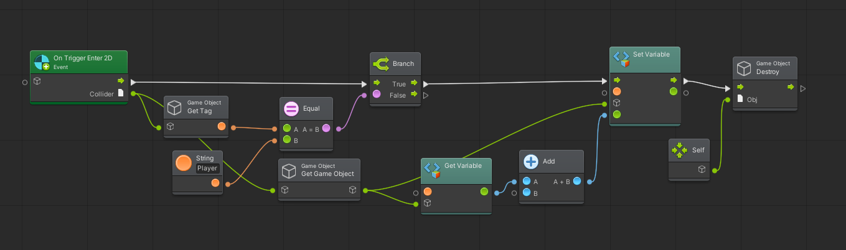

When the player collides with the key gameobject, the key gameobject would be destroyed and the player will gain 1 key.

**Flamethrower macro**

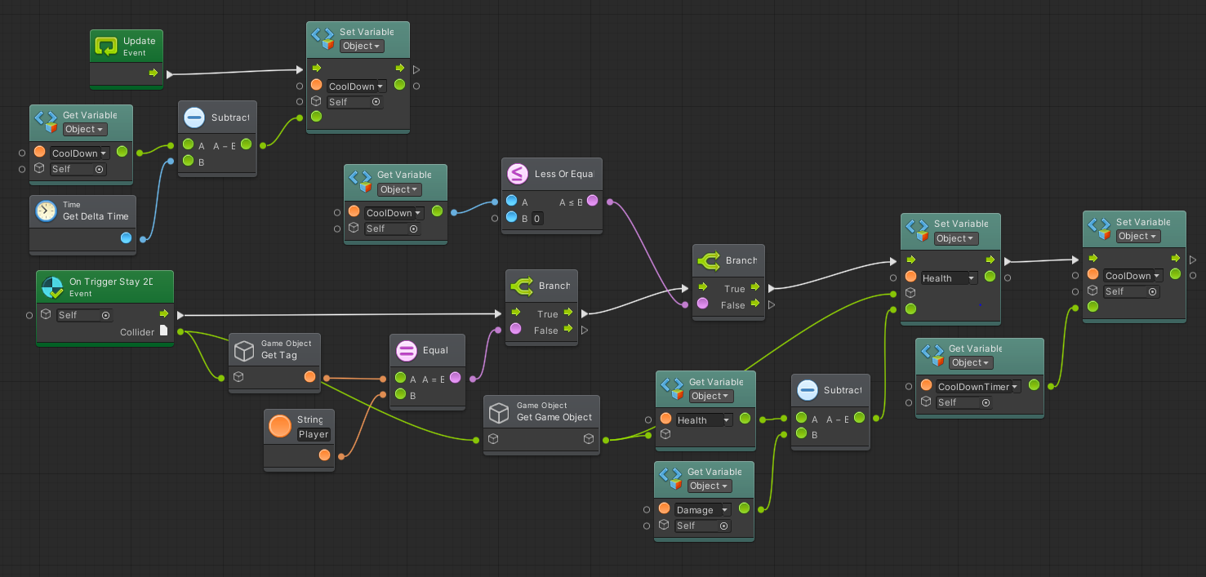

Explanation: The update event will constantly reducing the cooldown timer by delta time and when the player in contact with the flamethrower, the player will receive damage from the flamethrower if the cooldown is below 0 and if it succeeds, it will set its cooldown to the CoolDown Timer value.

**Shop NPC Macro**

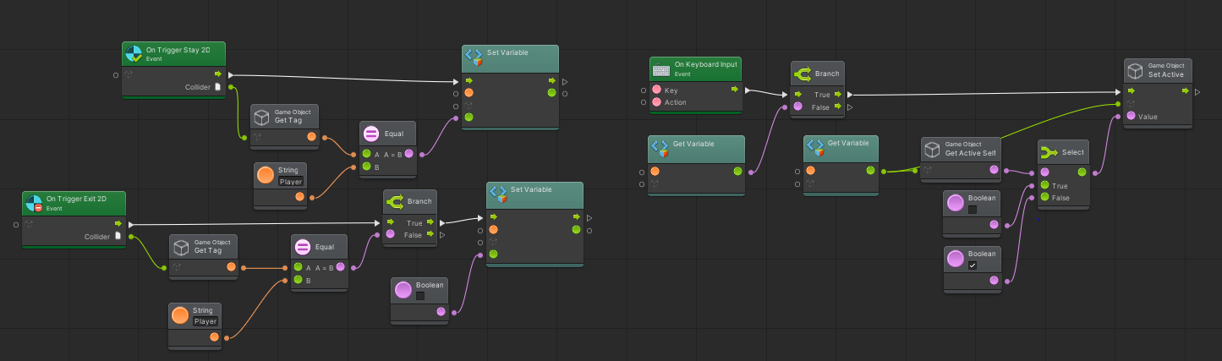

Explanation: When the player is staying in the Shop NPC area of collision trigger, the “IsPlayerInRange” in the shop npc gameobject variables will be set to active. When the “IsPlayerInRange '' variable is active and the player presses I key, a shop ui will be displayed where the player will be able to purchase items. When the player leaves the collision trigger of the Shop NPC, the “IsPlayerInRange” will be set to false and the player will not be able to trigger the shop display until the player is near the shop npc.

**NPC Embed Macro**

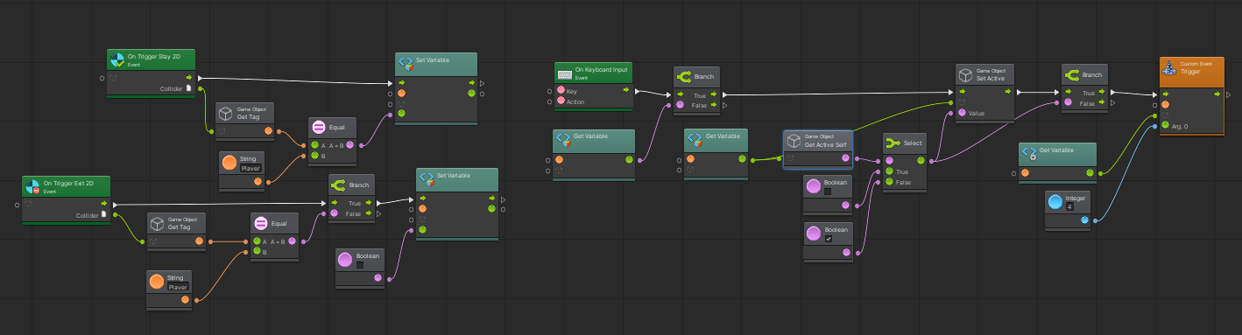

Explanation: It functions the same way as the Shop NPC macro except playing of different sound effects and displaying different game ui.

**Health bar Embed Macro**

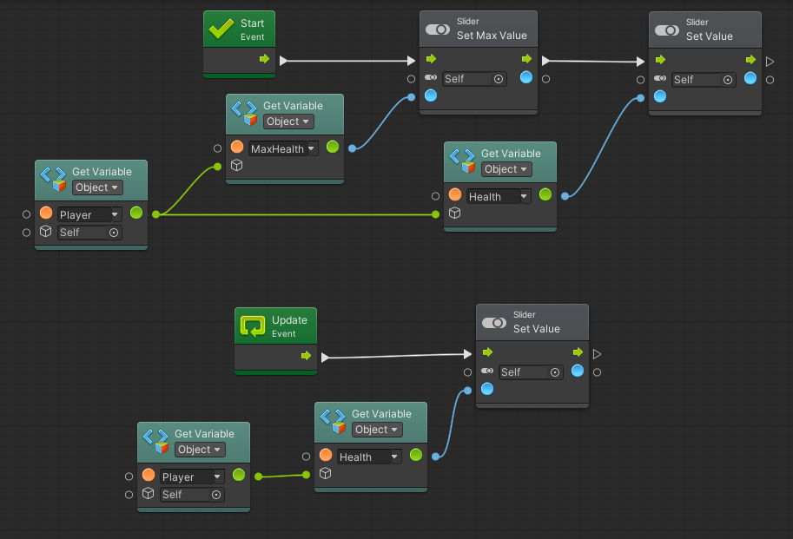

Explanation: the player will set its max health and health into the slider variable. As the update event continues to run continuously, it will get the player’s health and update the value in the slider.

**Bullet UI Embed Macro**

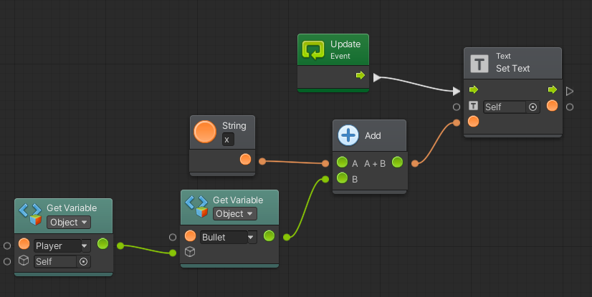

Explanation: In the Update Event, it will consistently get the number of bullets left from the player and display it on the UI.

**Coin UI Embed Macro**

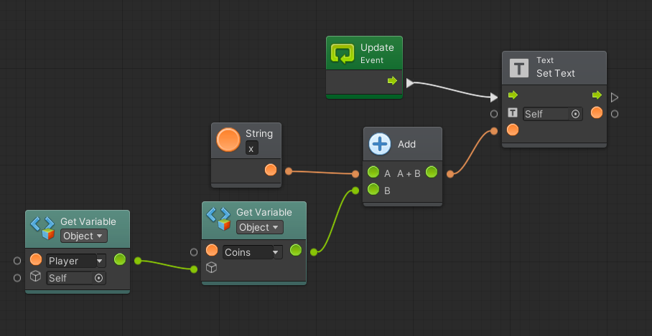

Explanation: In the Update Event, it will consistently get the number of coins left from the player and display it on the UI.

**Key UI Embed Macro**

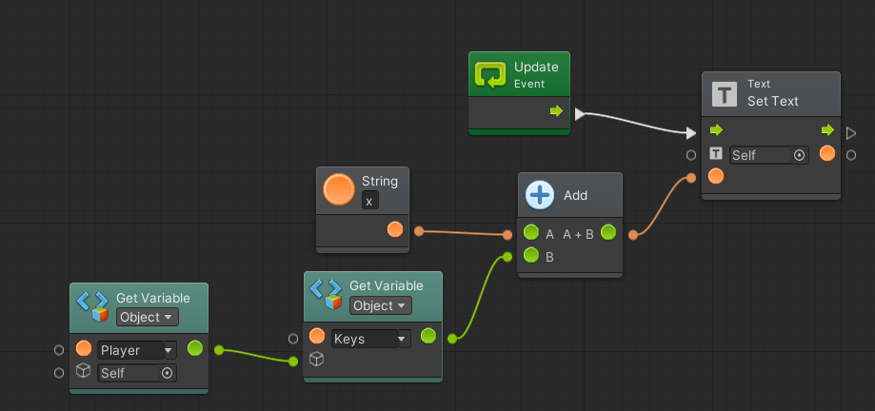Explanation: In the update event, it will consistently get the number of keys left for players to open the door.

**Swap Weapon Macro**

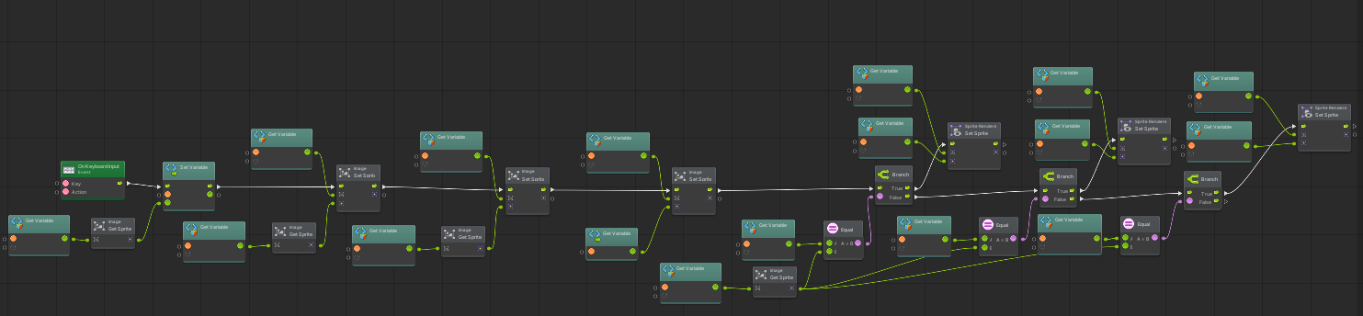

Explanation: When the player presses the P key, there will be a swap in the weapon where weapon1 becomes weapon3, weapon2 becomes weapon 1 and weapon 3 becomes weapon 2. afterwards it checks the ui sprite that which main weapon is currently using and swap it accordingly if conditional checks.

**Shop Macro**

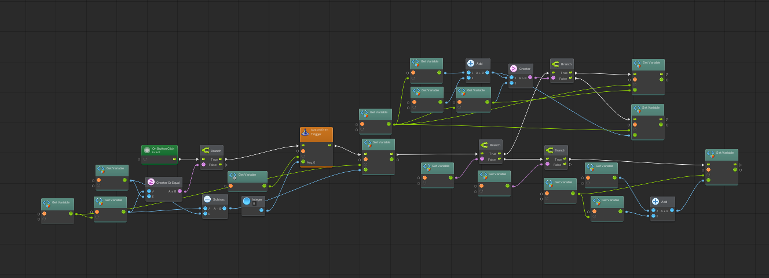

Explanation: When the player has made his choice and pressed the button, it will play a sound effect when bought something from the shop successfully, the coins from the player will be firstly checked if the player has enough coins to buy it first.If the have enough money, the player coin is being deducted and updated. Upon successful purchase, it will check if the item bought effect is health or bullet add it into the player variables accordingly.

**Player Macro**

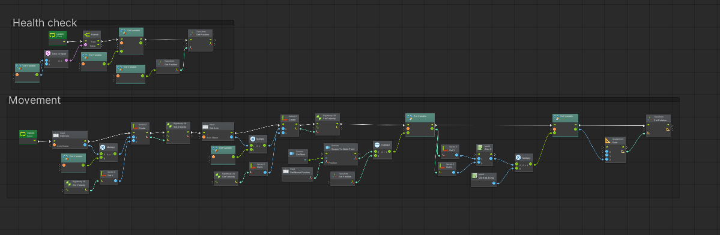

In the health check group iit be constantly checked if health flows below 0 and needs to respawn. In the movement. In the movement group, player movement is being through the “horizontal” and “vertical” axis which gets from presses A and D, W and S respectively. The mouse position is also being tracked such that the player will be constantly face at the mouse by doing math calculation and then rotate the player.

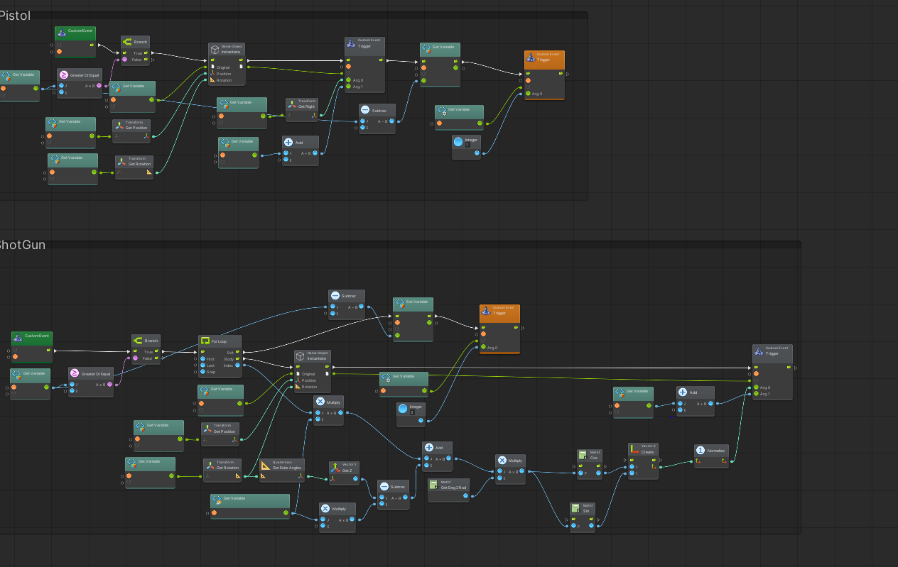

Both pistol and shotgun are using the same code where the bullet is being instantiated. The only difference is the number of bullets being spawn at the same time, damage output per bullet and different sound effects.

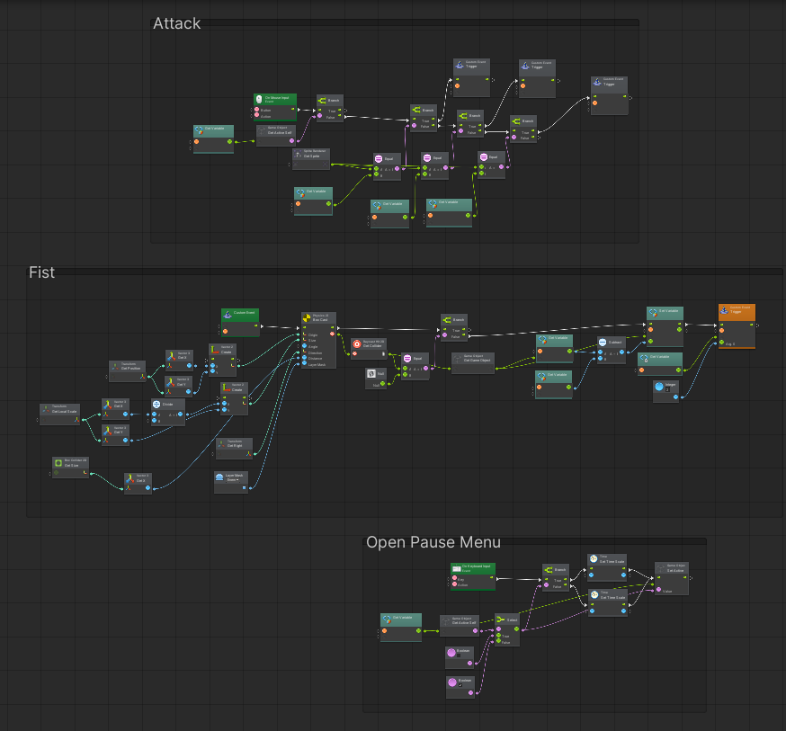

When the player attacks with pressing the left mouse click, it will check with the main weapon that the ui is displaying and trigger the custom event accordingly (Fist/Pistol/Shotgun). If it is fist custom event, it will do a box cast in front of the player and set the targeted layer to be on the enemy, if multiple enemies are in that box cast only one of the enemies will get the damage from the player and also plays a hit sound effect. When the player presses Escape key, it will trigger the pause menu and stop everyone’s action by setting the time scale to 0 and pop up a pause menu UI.

**Enemy Melee State Flow**

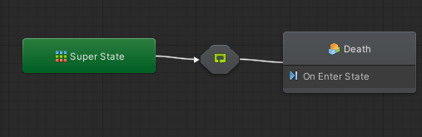

Explanation: It contains a super state (aka the alive state) being connected to the death State where it will be triggered when

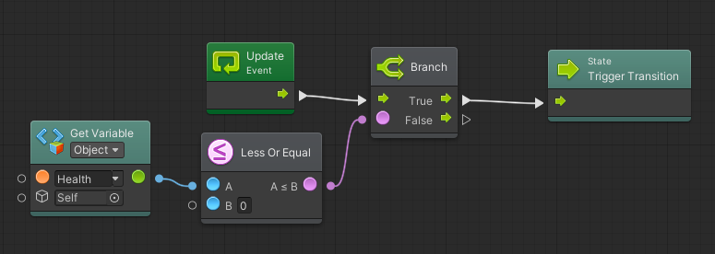

That enemy health falls below 0.

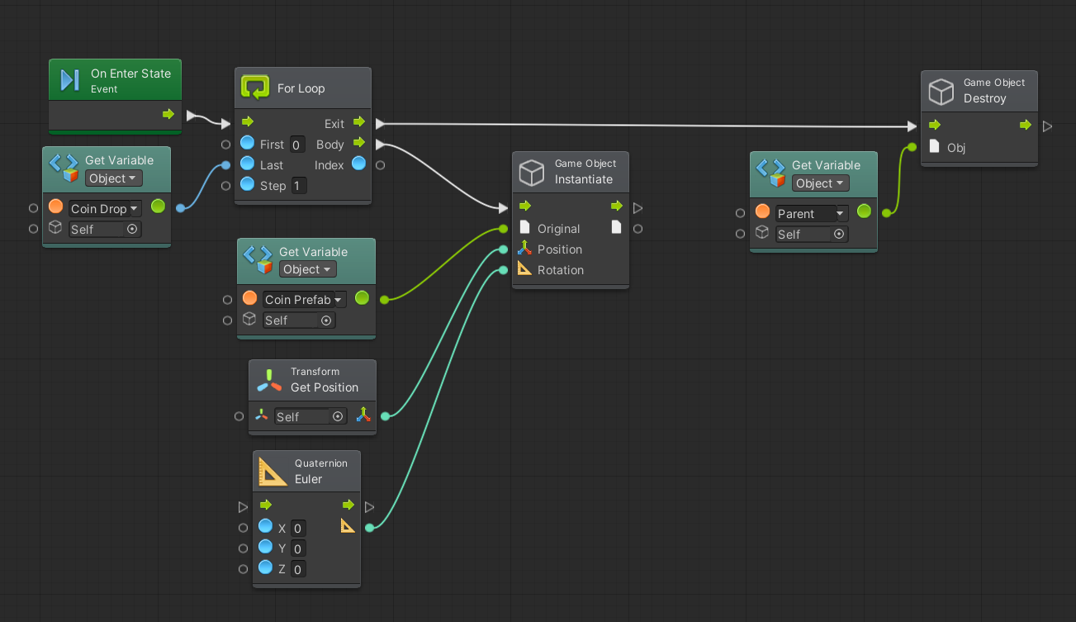

And before the enemy is destroyed, it will spawn coins on that location according to its number of coin drops. Inside the super state,

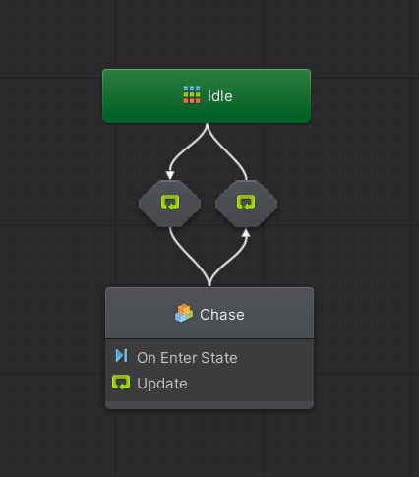

There will be an idle state and chase being connected to one another, where the transition of idle state to chase state is by

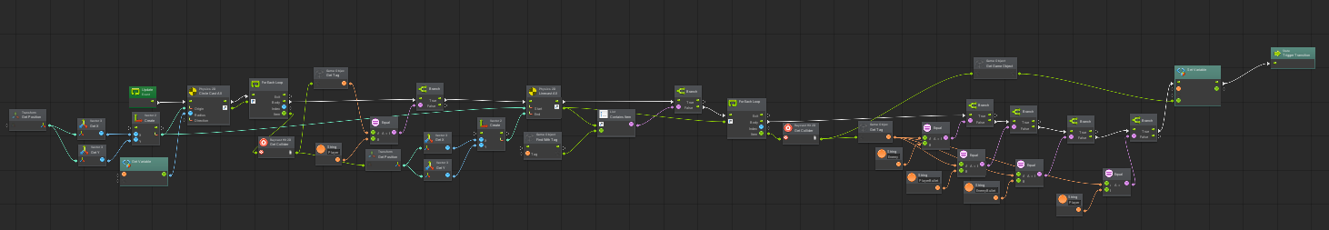

Constantly checking by doing a circle ray cast over itself and search for all collider’s gameobject tag that is the “player” tag.If the player tag is found,it will do a line cast to the player and check it the collider list contains the “wall” tag which is obstruct the view of sight from enemy, it is true, the player will be ignored, else if it is false, the scene transition will be triggered to chase state and get the player gameobject. Inside the chase state below,

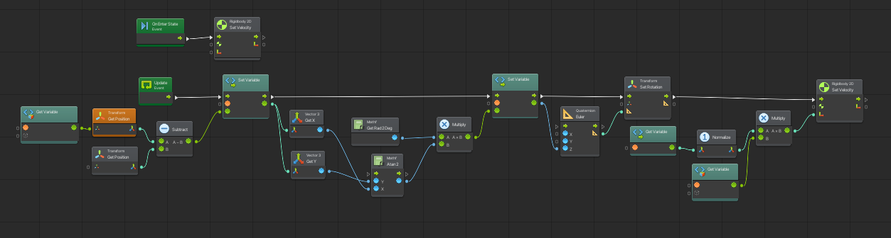

It will constantly get the player position and get the direction vector to set the velocity and at the same time calculate the angle needed to rotate to face towards the player.The way that the enemy will stop chasing the player is when

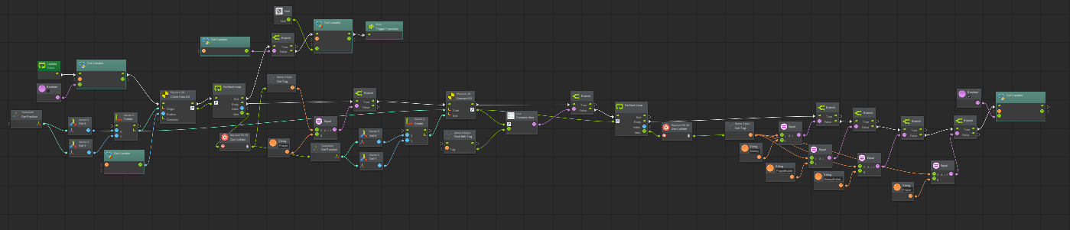

The player is longer on the enemy sight of viewing or exceeds the detection radius of the enemy.In the idle state,

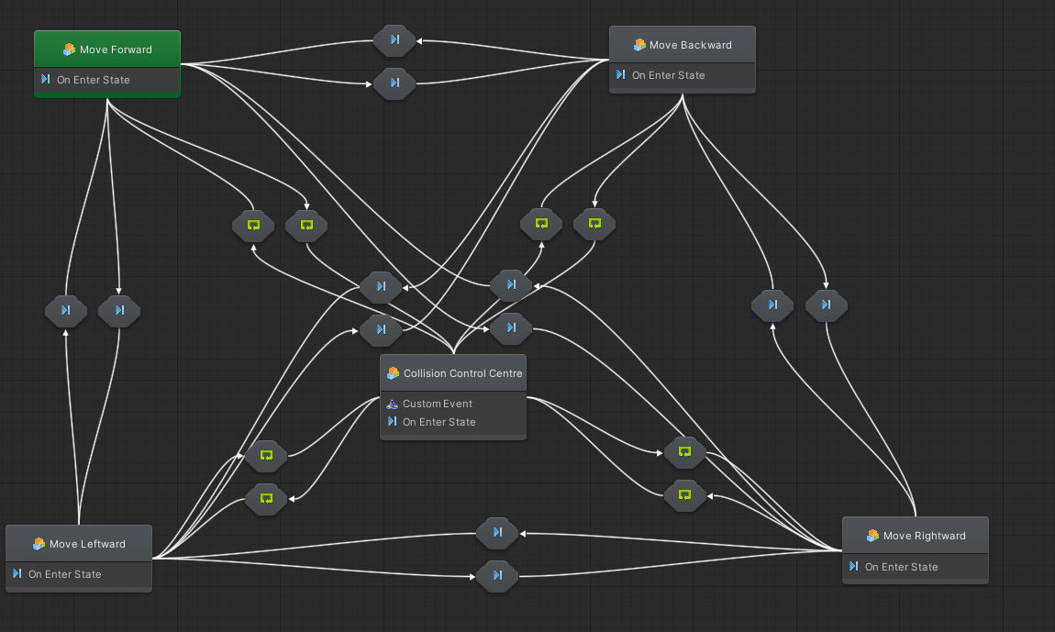

The enemy will move randomly by the Timer Macro

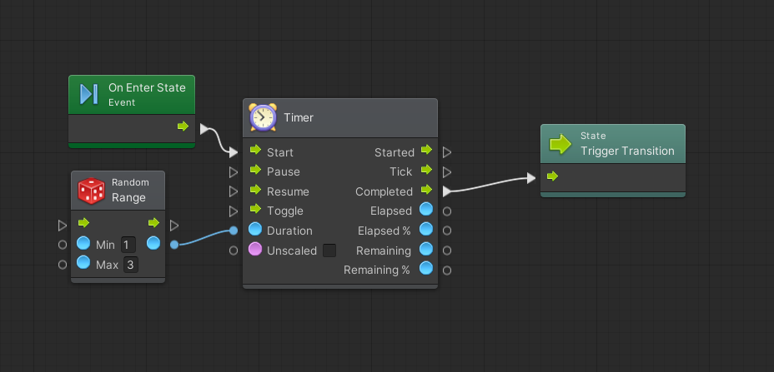

Where it will have random timing to do the countdown before it is being transit. But when the enemy is going to hit the wall

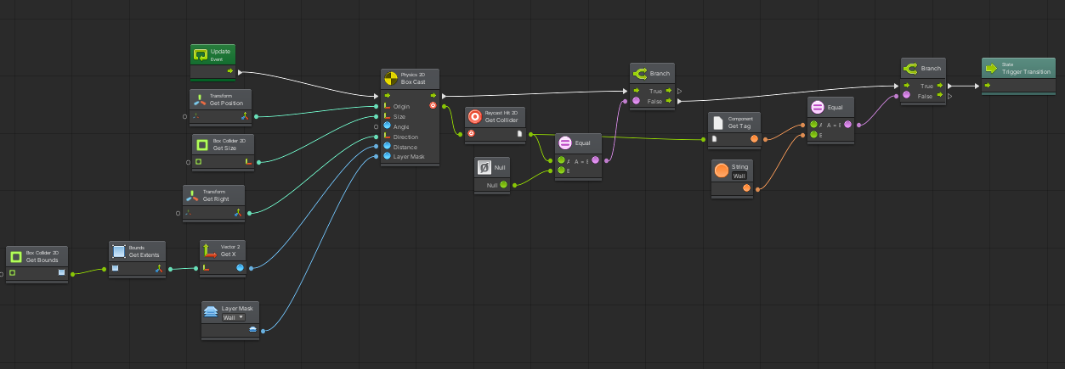

This script will be triggered and transit it to the collision control center where

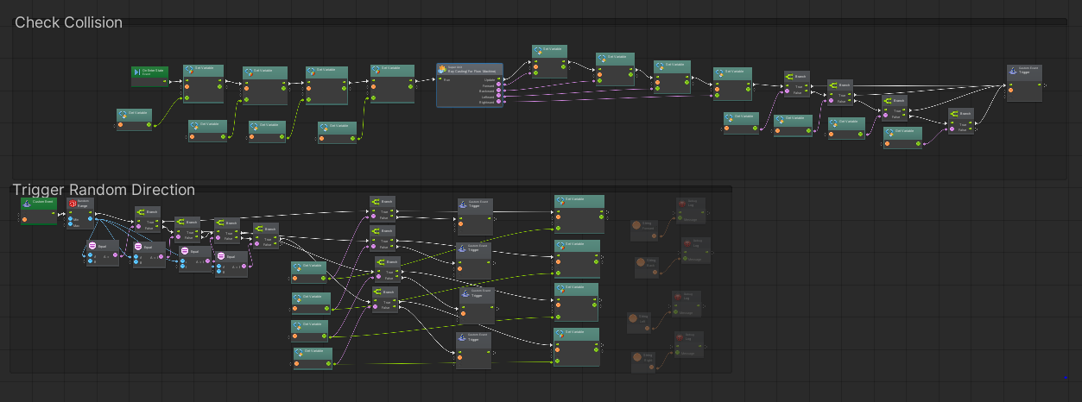

It will get all the possible direction from ray casting macro and afterwards triggering the random possible direction to turn to. Inside the Ray Casting (For flow machine) macro

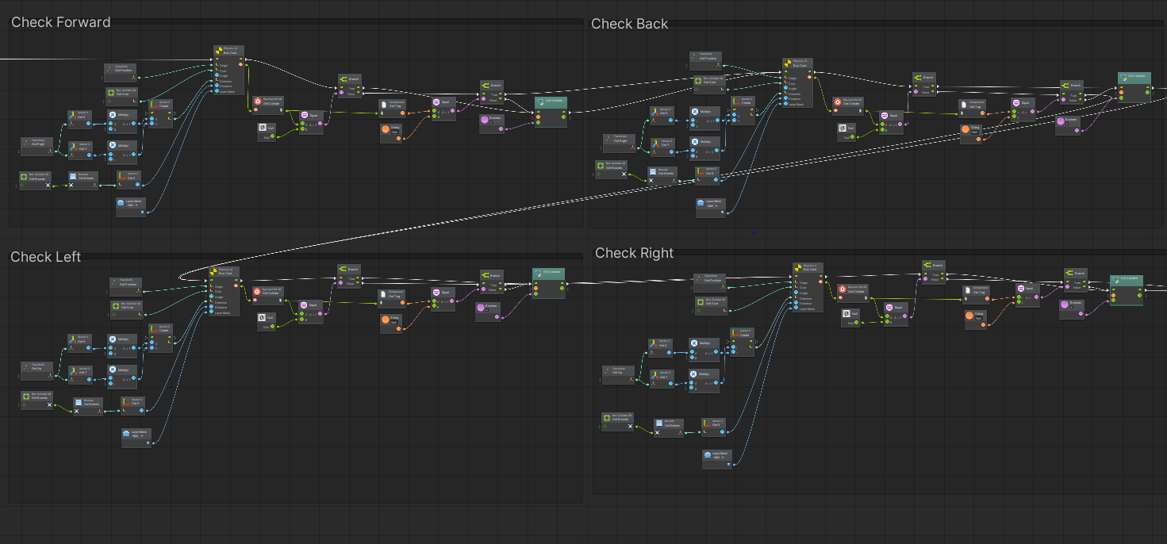

It will handle the enemy direction of front, behind, left and right to check if it will hit the wall which then sends it to the output. After getting the possible direction from the collision control centre,

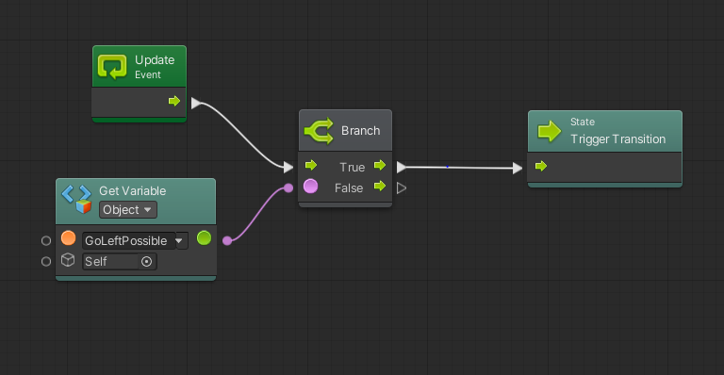

It will check which connector has the correct variable to transit to the next flow machine. When in the direction flow machine.

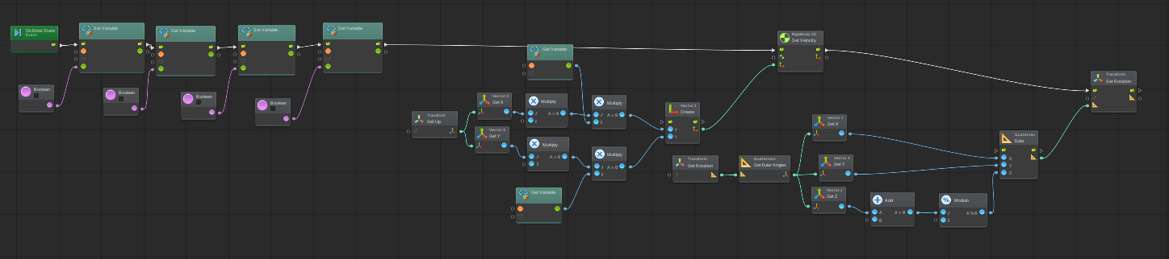

The script will reset the possible direction that is gotten from the collision control centre to prevent it from skipping the checking for possible route in the collision control centre and the get the direction vector that is intended and multiply it with the speed and the lastly set the rotation of the enemy.

**Attack Macro**

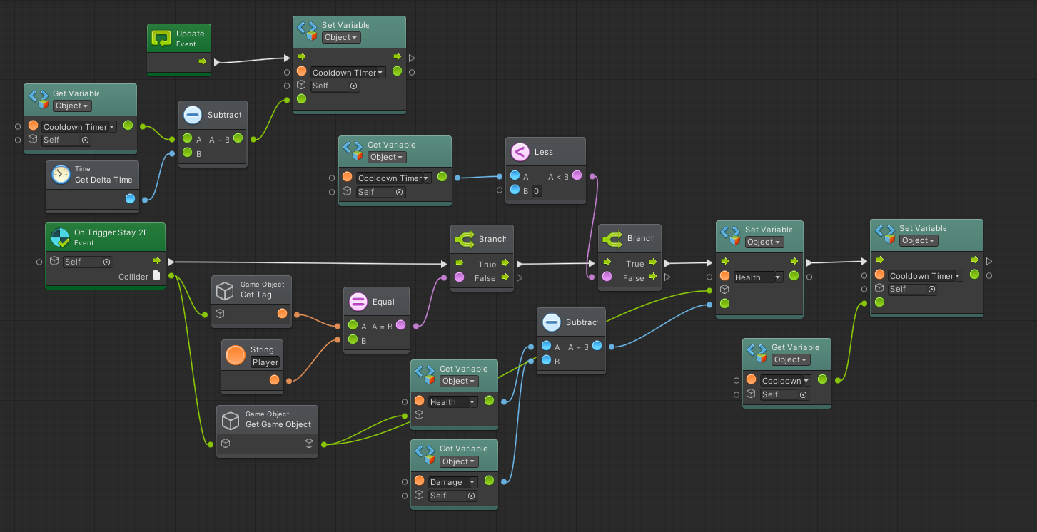

Explanation: when the enemy is close to the player, this gameobject collider that is attacked to the front of the enemy will detect the players and make the attacks when the cooldown reaches 0 or below.

**Range Behaviour Macro**

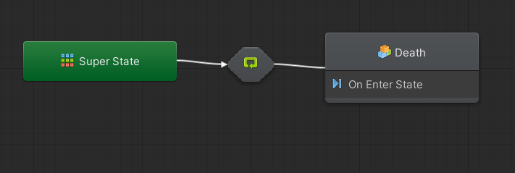

Explanation: behaves the same as the melee enemy, the only is difference is where the enemy will stop and shoot at player without needing it to get close to player.Inside the stop and shoot flow machine

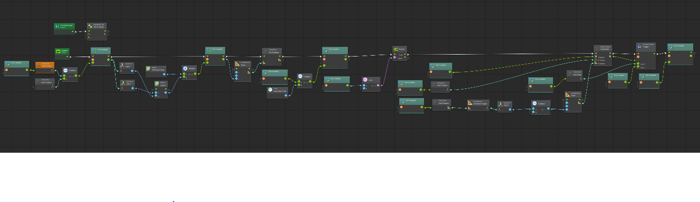

Where it will get the player location and rotate towards the player and shoot at the player.

**Range Boss Shotgun Macro**

Explanation: Use it in mini range boss and range boss gameobject. Behaves the same way as the range enemy except now the range boss have a new flow machine

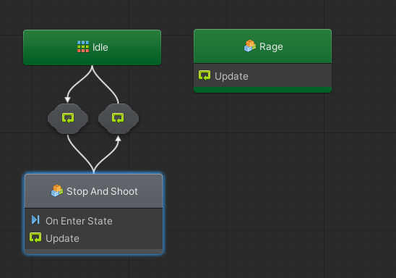

That is the Rage flow machine where it will

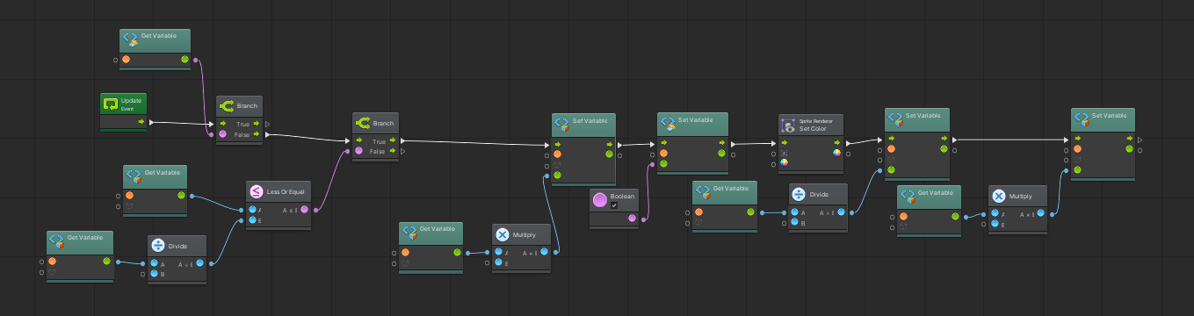

Check if the health is below 50% which the enemy will get an overall enhancement in their movement speed, attack cooldown and their damage output to players if the condition is fulfilled.

**Enemy Range Boss Macro**

Explanation: works exactly the same as the Range Boss Shotgun Macro except that now the Idle state is empty as the enemy boss is not meant for it to be moving around.

**Melee Boss Macro**

Explanation: works the same way as the melee enemy except itself have an ability to trigger rage

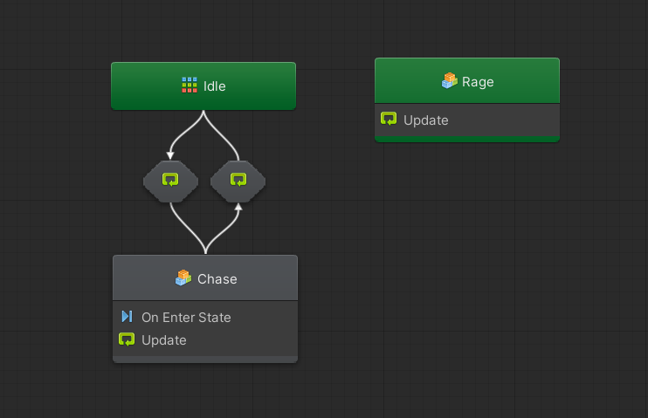

Which has the capability to buff its statistics when the health falls below 50%.

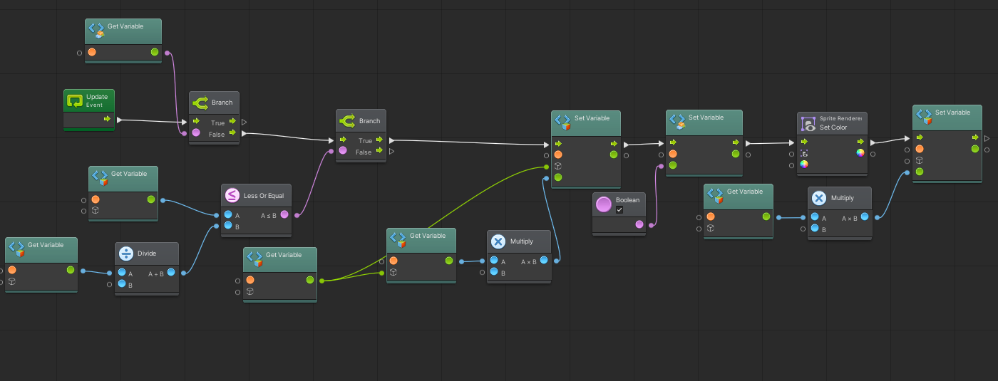

**Dummy Enemy Macro**

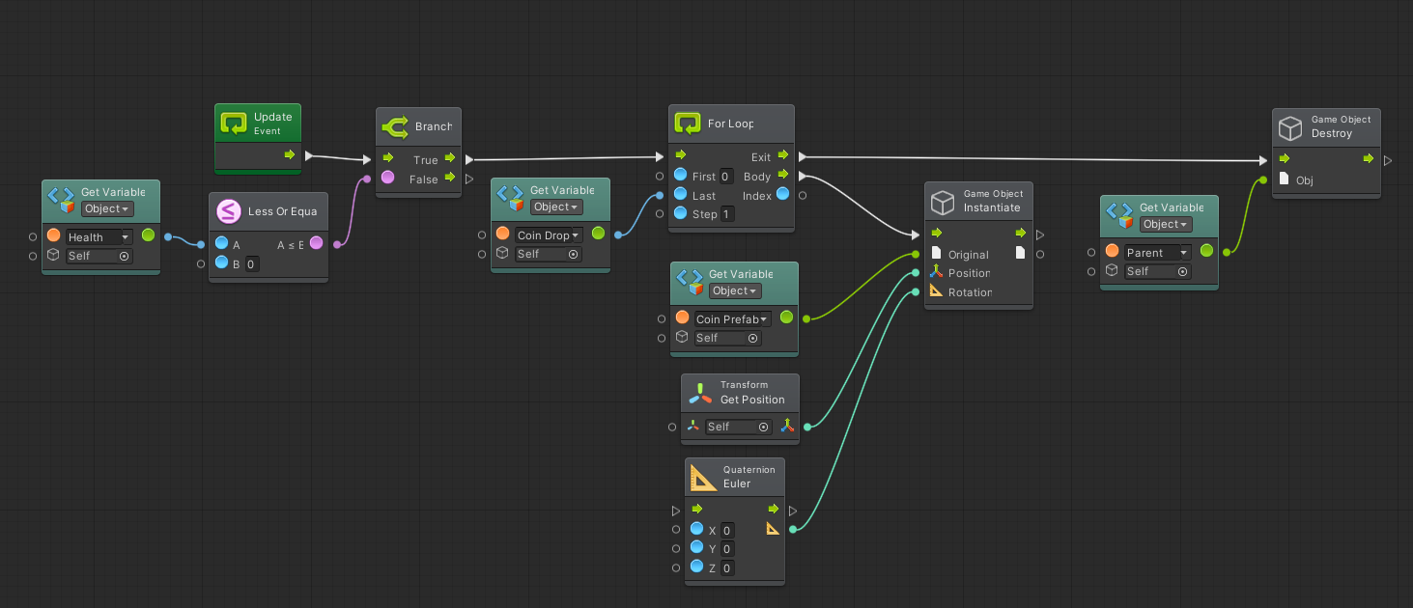

Explanation: As for dummy enemies, since it's being used as a shooting target practice for players in the early game, it will not have the ability to attack, patrol around and also to chase the player.